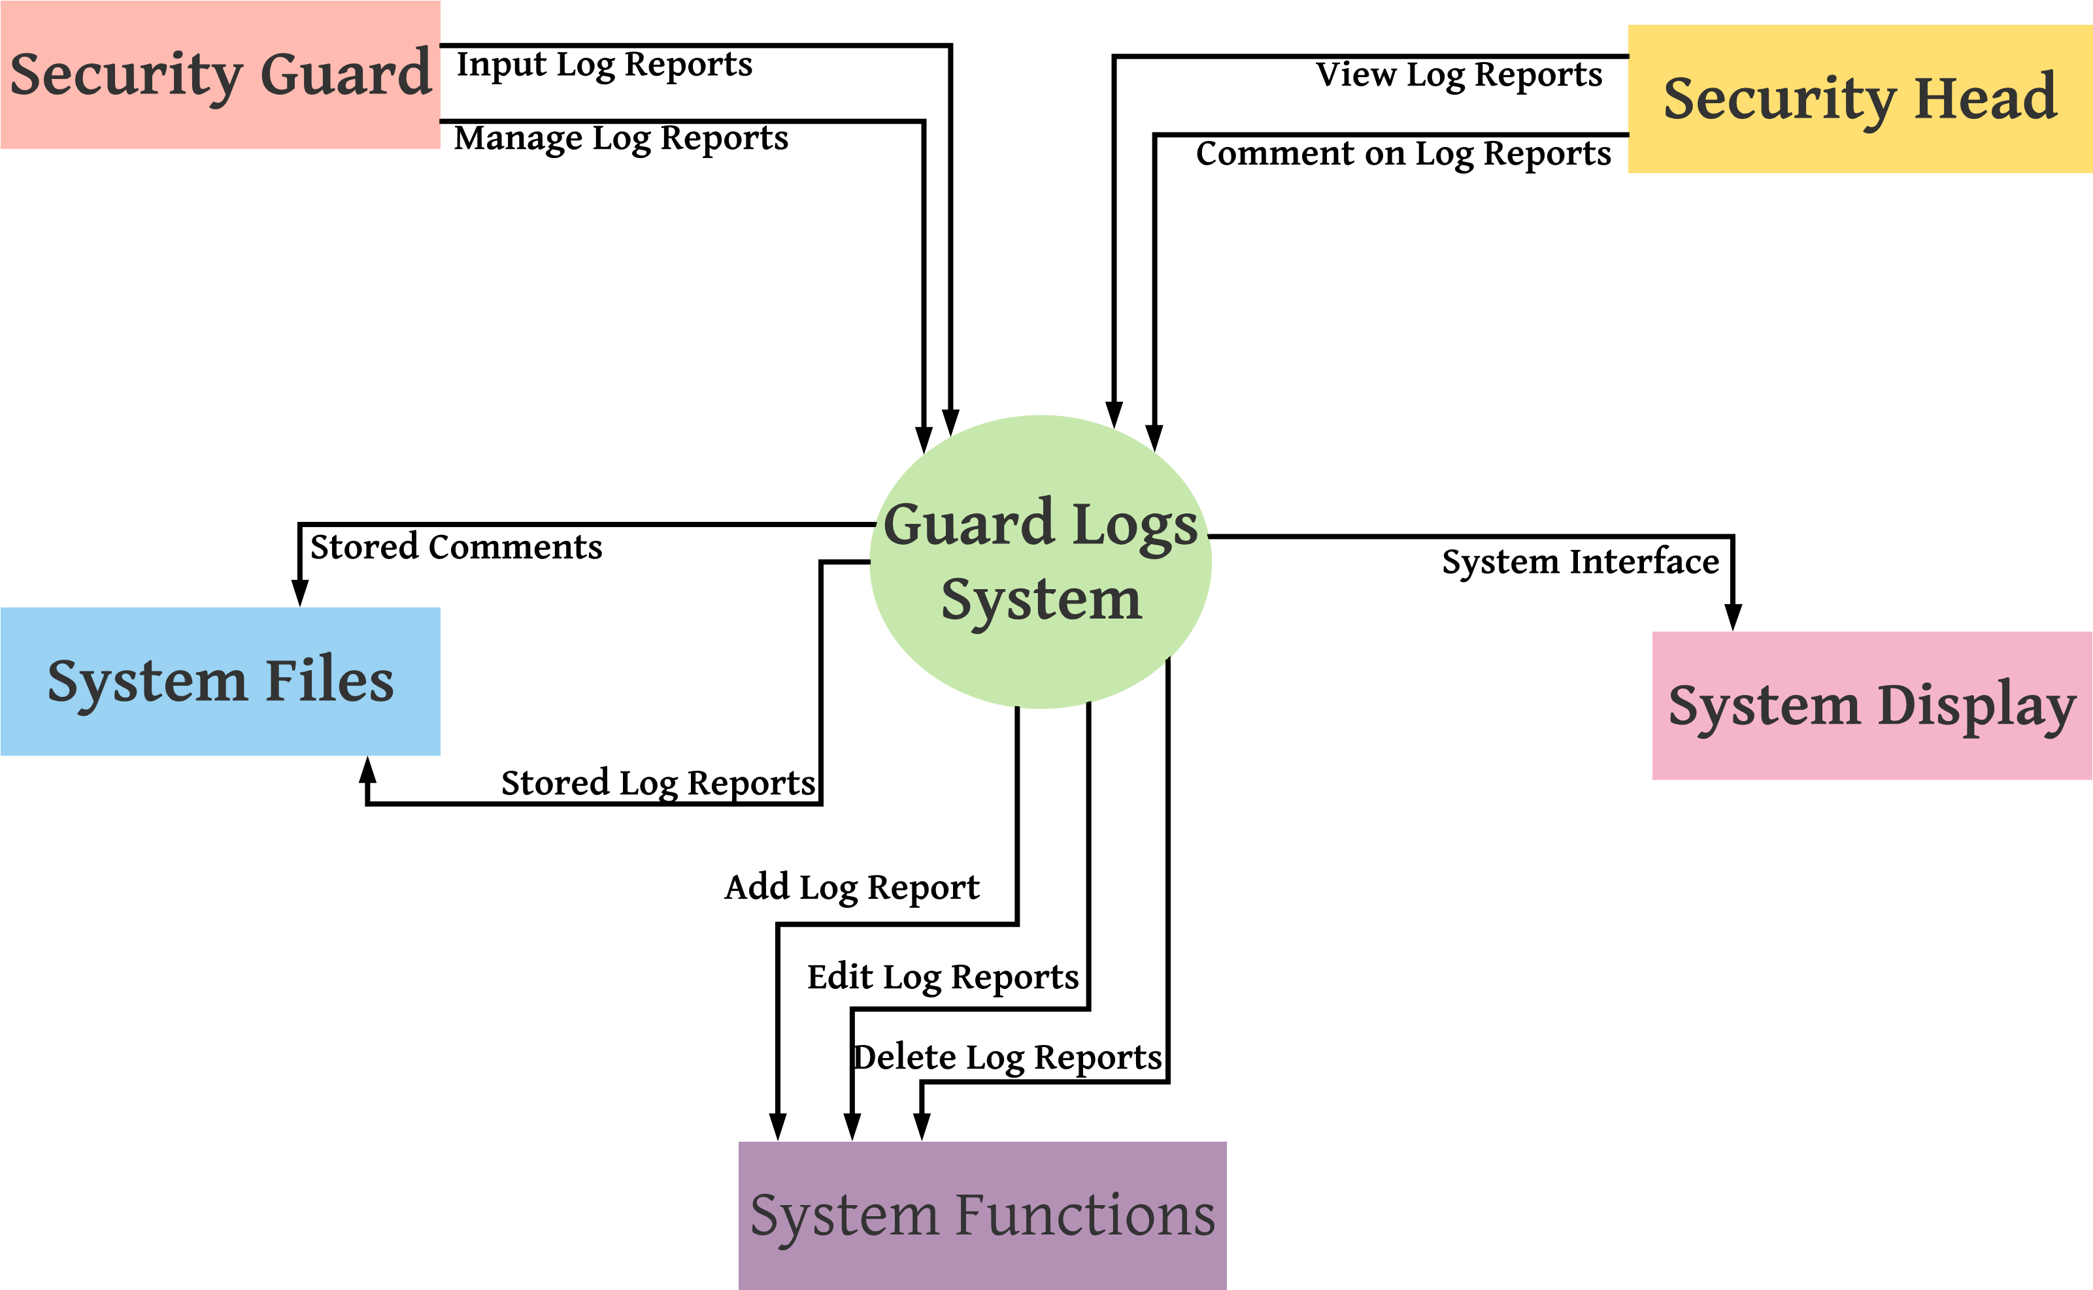CONTEXT LEVEL DIAGRAM (level 0)

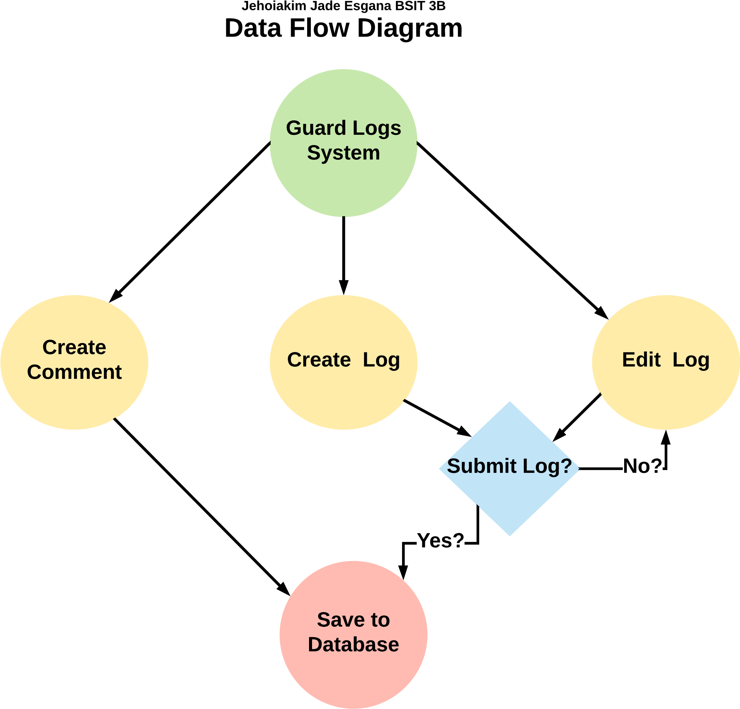c­­

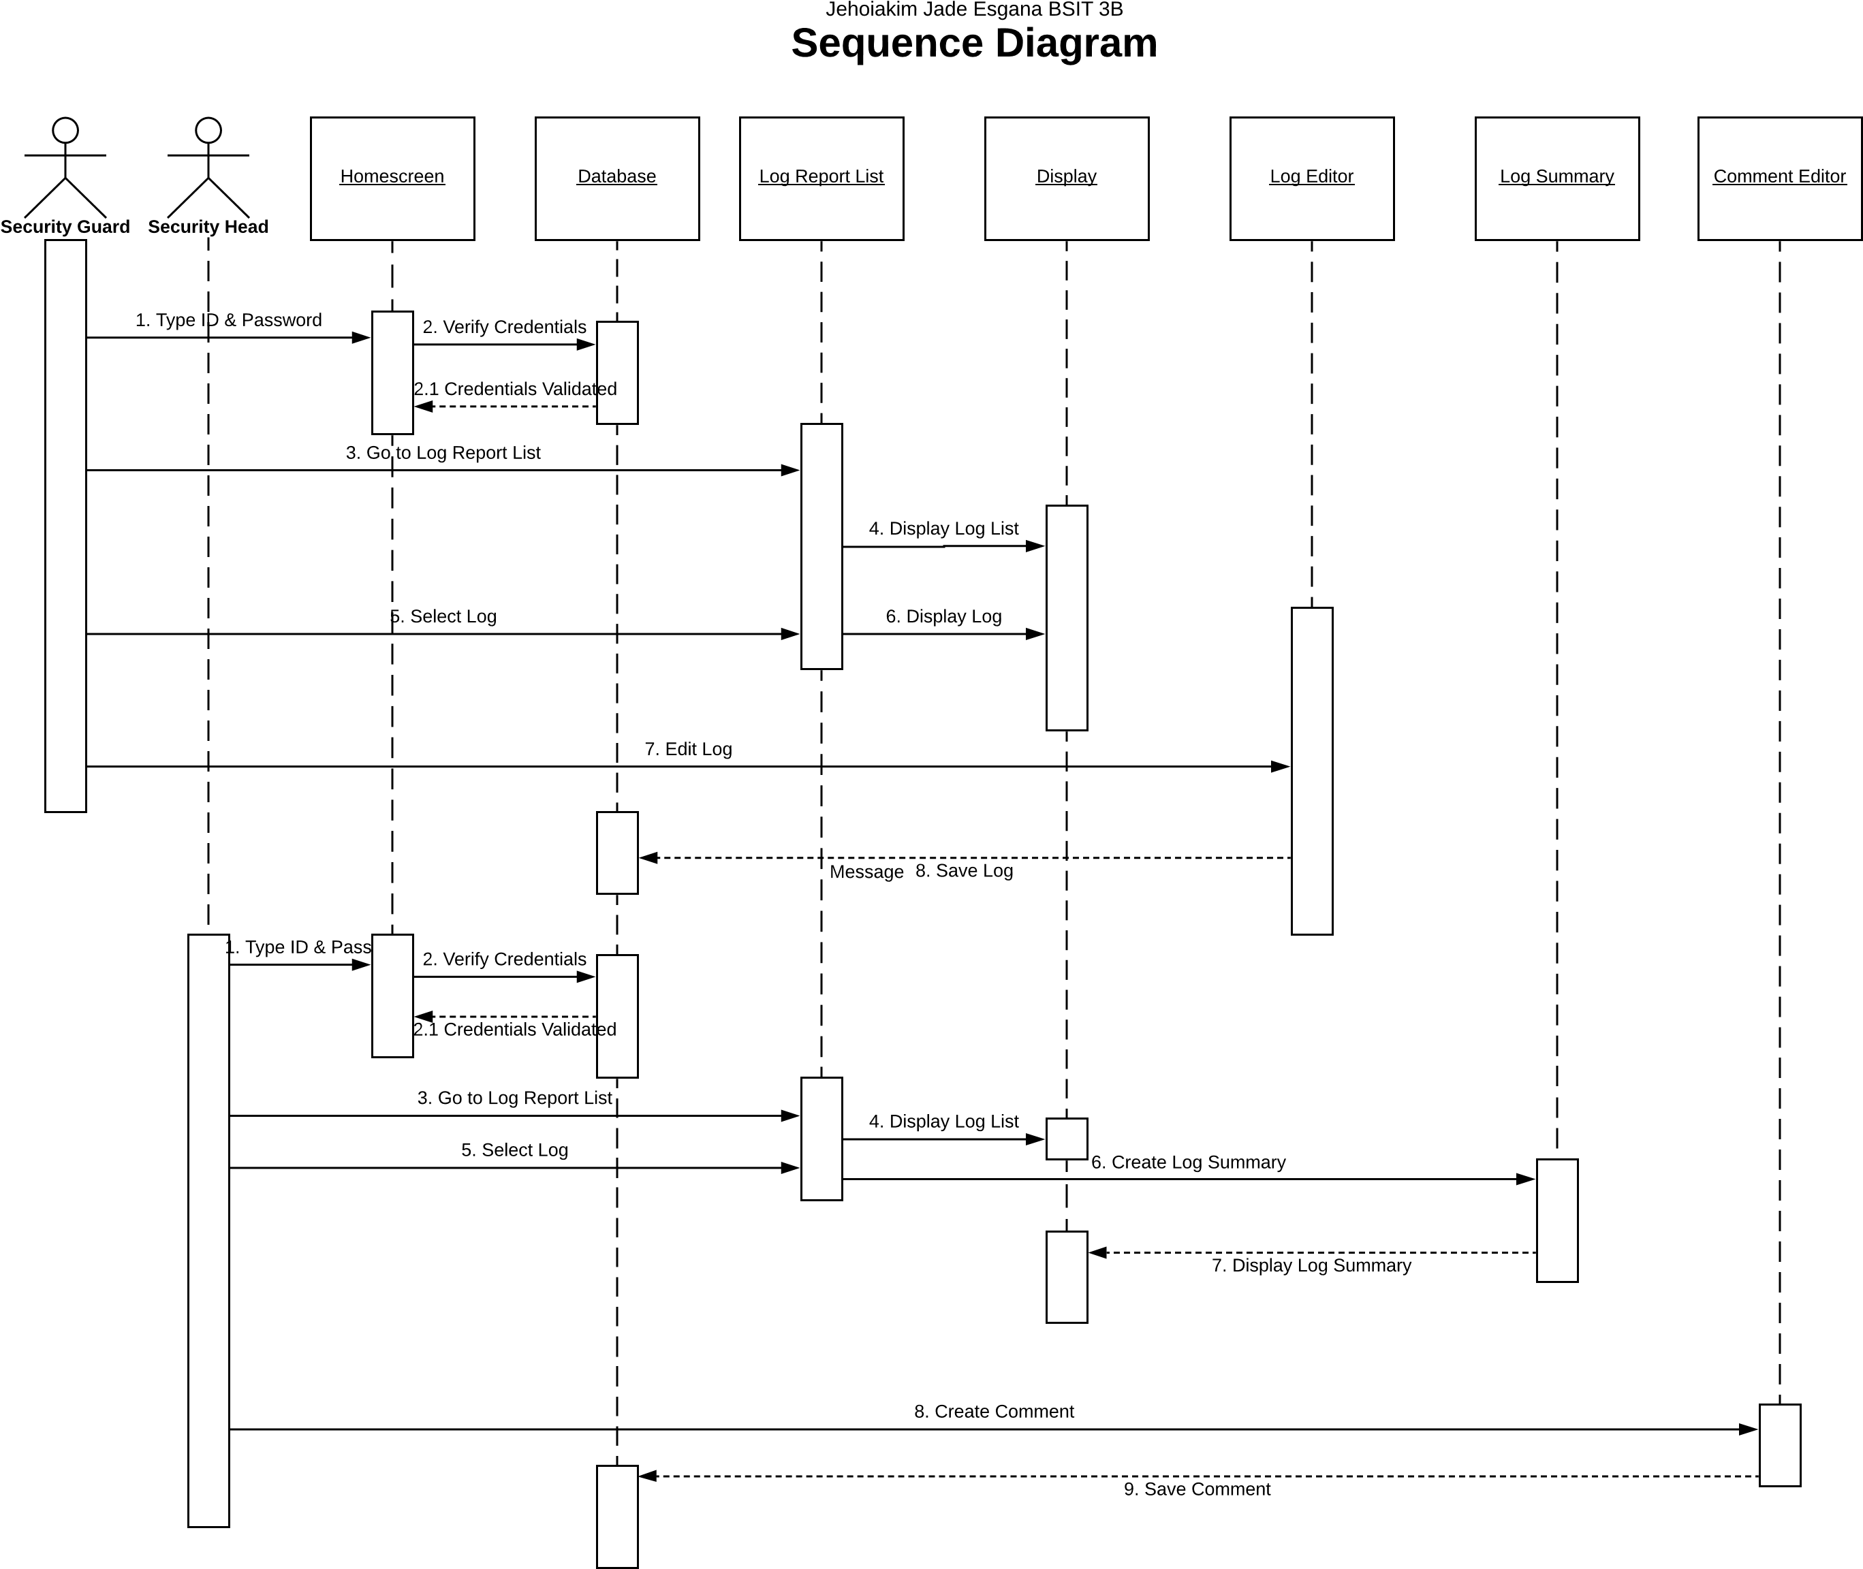

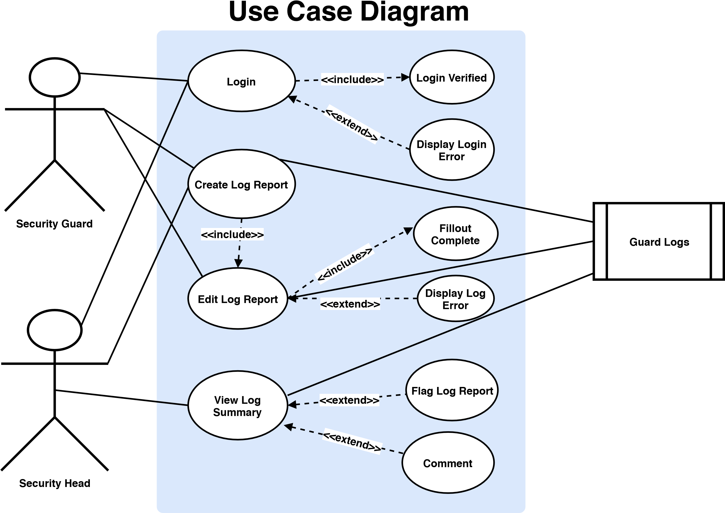

**SYSTEM ARCHITECTURE DIAGRAM**

**System**

**Login**

**Interface**

**Security**

**Guard List**

**Interface**

**Log Report**

**Editing**

**Interface**

**Comment**

**Editing**

**Interface**

**Account**

**Verification**

**Account**

**Database**

**Log Summary**

**Database**

**Security**

**Guard List**

**Database**

**Log Report**

**Completeness**

**Verification**

**Comments**

**Database**

**Log Reports**

**Database**

Use Case # 1 A Security Guard finished his 10 hours shift and logs in to his System Account.

**User Clicks the**

**"Login" Button**

**User Types his ID**

**& Password**

**Account Valid?**

**No**

**User fills the**

**blank spaces with**

**Log Report**

**Yes**

**User Clicks the**

**"Finish Log"**

**Button**

**Log Report**

**Complete?**

**No**

**Log Report Saved**

**Yes**

Use Case # 2 A Security Guard edits his Log Report due to a flag or comment from the Security Head.

**User Clicks the**

**"Login" Button**

**User Types his ID**

**& Password**

**Account Valid?**

**No**

**User Clicks the**

**"Edit Log" Button**

**Yes**

**User Edits the**

**Content of the**

**Log Report**

**Log Report**

**Complete?**

**No**

**Log Report Saved**

**Yes**

**User Clicks the**

**"Finish Log"**

**Button**

Use Case # 3 The Security Head views a Log Report of a Security Guard

**User Clicks the**

**"Login" Button**

**User Types his ID**

**& Password**

**Account Valid?**

**No**

**User Clicks a**

**Security Guard**

**Name**

**Yes**

**User Clicks**

**"View Log**

**Reports" Button**

**System Displays**

**List of Security**

**Guard Names**

**User Clicks a Log**

**Report via the**

**"View Log" Button**

**System Displays**

**the "Summary" of**

**the Log Report**

**System Displays**

**List of Log**

**Reports**

**User Clicks the**

**"Login" Button**

**User Types his ID**

**& Password**

**Account Valid?**

**No**

**User Clicks a**

**Security Guard**

**Name**

**Yes**

**User Clicks**

**"View Log**

**Reports" Button**

**System Displays**

**List of Security**

**Guard Names**

**User Clicks a Log**

**Report via the**

**"View Log" Button**

**System Displays**

**the "Summary" of**

**the Log Report**

**System Displays**

**List of Log**

**Reports**

**User Clicks the**

**"Flag Log" Button**

**User Clicks the**

**"Add Comment"**

**Button**

**User Types his**

**Comment**

**User Clicks the**

**"Save Review"**

**Button**

**Review Saved**